**Story of Uks**

**The Story of Uks**

*‘Reflection’ as it means in Urdu, Uks strives to mirror a neutral, balanced and unbiased approach towards women and issues facing them within and through the media.*

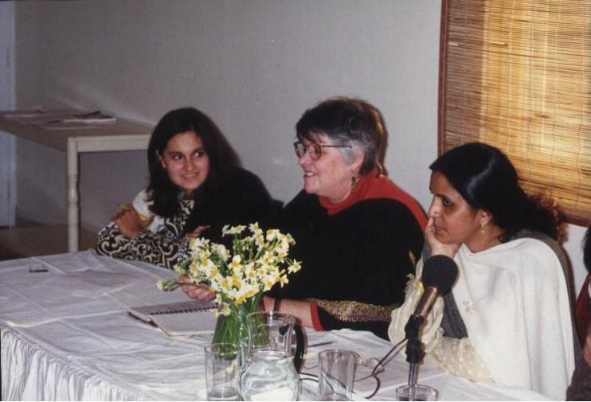Conceived in March 1997, Uks was formally established in December the same year as a result of a panel discussion on ‘Empowering Women Through Media’ chaired by Ms. Jane O’Reilly, founder member of Ms. Magazine (USA). What initially served as a topic of discussion became the representative slogan for all Uks activities.

Uks is the first of its kind research, resource and publication center whose all activities revolve around gender equality, women's development and sensitizing the media over women and gender related issues. Being an advocacy and rights-based group Uks seeks to raise awareness and assist implementation of its goals and ideals. Women-media relationship is one of the key areas of focus for the organization; a concern not given its due projection by organizations working on women’s rights.

For the past two decades, Uks has made various individual and collaborative efforts to change the mindset of the media towards women and their issues. Monitoring the media, conducting research on emerging trends from the perspective of gender and women development and undertaking hundreds of trainings and workshops to raise awareness and change behaviours about crucial issues amongst media are to name a few.

There is no denying the power and impact of media on our lives and its ability to showcase, change and sometimes determine one’s ideological beliefs. Realizing this controlling influence of the media, Uks aims to utilize, in its entirety, the services of our media to effectively improve the present status of the Pakistani woman and to highlight the importance of her role in national development.

In its endeavor to empower women through media, Uks has built up a team of professional media persons and researchers to view the various aspects of women-media relationship.

Not only this, the Center has also won the support of prominent journalists, human and women's rights activists, academia and other like-minded groups.

.

**Uks’s firsts**

1. **Publication of first-ever study on monitoring of print media on the portrayal of Women – Changing Images- 2003**

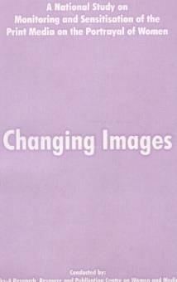

1. **Resource material, based on clippings from newspapers, magazine scanned daily, on the projection of women in the print media- since 1998**

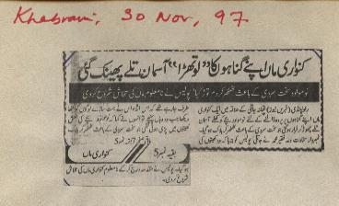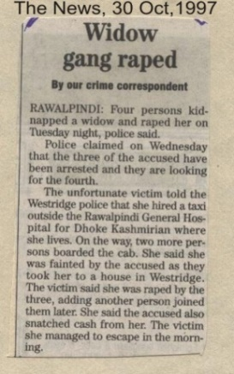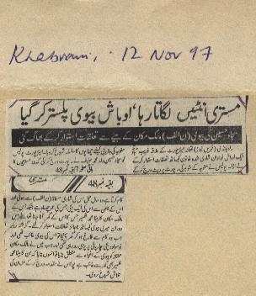

1. 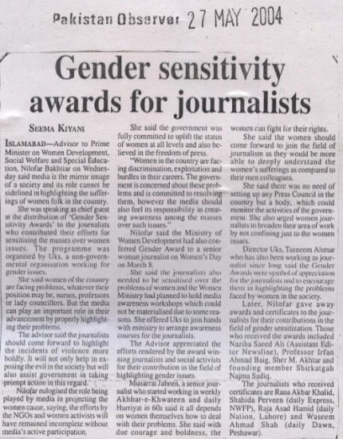**Announcement of Gender-Sensitivity Awards for Journalists, first time in the history of Pakistani journalism - 2004**

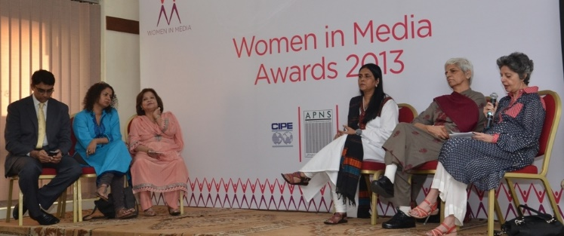

1. **One of the first organizations in Pakistan to sensitize the media on reporting on HIV and AIDS in a gender sensitive manner**

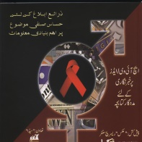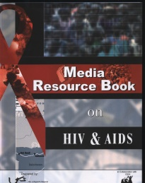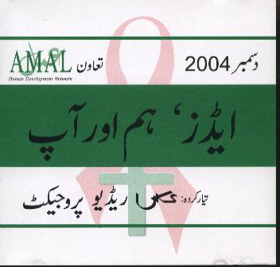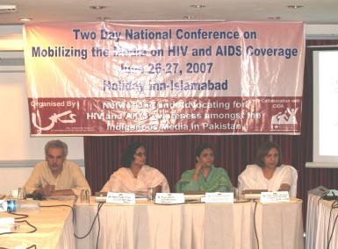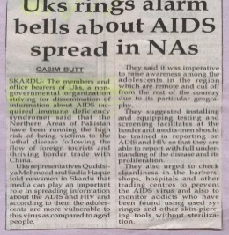

1. **One of the first organizations to train and sensitize the media on how to report on disasters with a gender lens in the aftermath of the earthquake of October 8, 2005**

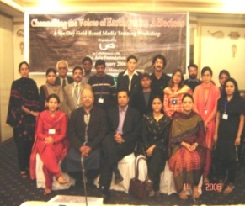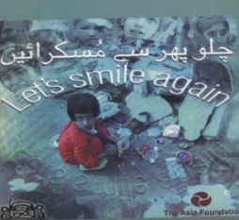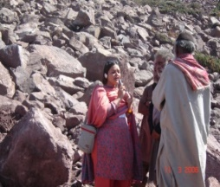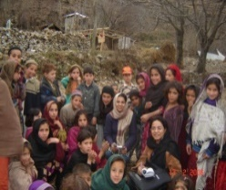

1. **First Civil Society Organization in Pakistan to own an in-house state-of-the-art Radio Production House -2003**

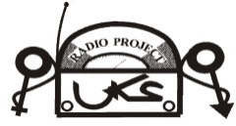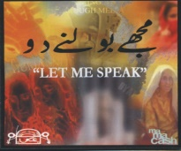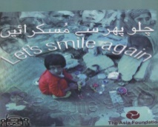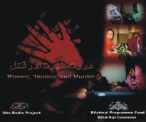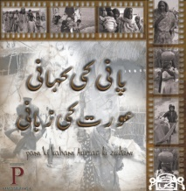

1. **Uks Annual Desk Diary- Our Trademark;** A collector's item with a new theme every year on women’s development, represented through press clippings

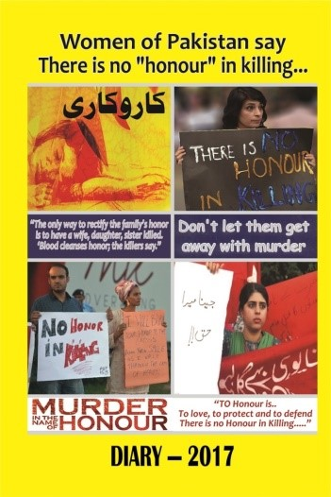

1. **First NGO in South Asia to compile and disseminate a gender-sensitive code-of-ethics for the print media in Pakistan- 2007. Uks revised the ethical code and included clauses for Electronic media as well in 2013.**

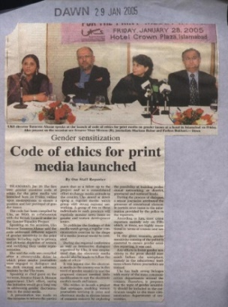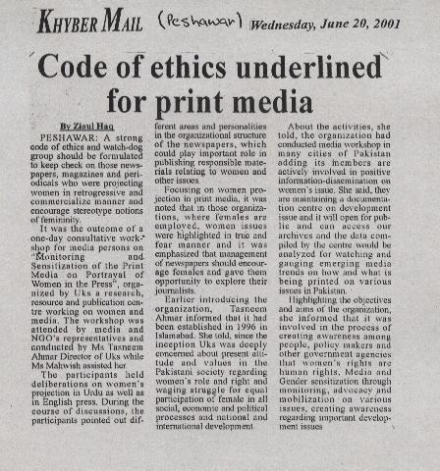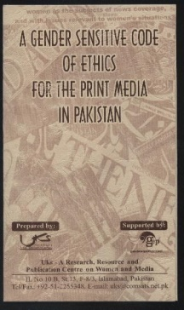

1. **Pakistani Women’s Media Network - 2008;** an informal, non-hierarchical group of women media persons working in the media committed to raising voices and concerns against gender-based violence, injustices and biases in the media and society.
2. Pakistan has been part of the [Global Media Monitoring Project (GMMP)](http://www.whomakesthenews.org./) twice– pulled together by Uks on both the occasions. GMMP is the world’s largest and longest longitudinal study on the gender in the world’s media.

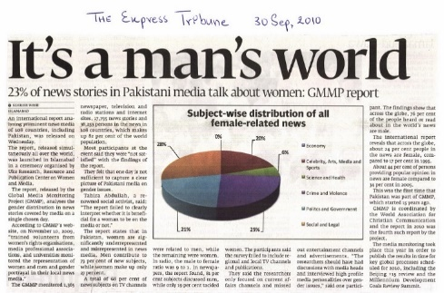



1. **Women’s Media Complaint Cell- 2014**

The first-of-its-kind complaint cell that caters to public complaints against gender-insensitive media content founded by Uks

.